(Approx. 818 words)

NUANCES IN ITUNES FOR WINDOWS
Managing your authorized computers, managing your credit card for iTunes purchases, and converting iTunes M4A files to other sound file formats
Part 3 of a 3-part series of articles
By John Krout, Presenter & Newsletter Contributor
Potomac Area Technology and Computer Society
https://www.patacs.org
jkrout.apcug.presenter (at) gmail.com

INTRODUCTION

As explained in Part 1 of this article series, when the COVID pandemic started, I felt that buying songs using iTunes had become an economical and safe alternative to buying used CDs at my local used CD retailer.

I ran into three problems, however. First, iTunes enforces a ceiling of five computers per account. The first problem was that I had “hit the wall,” meaning I had authorized iTunes on five computers, four of which were dead and gone. The only one I still had in hand was my laptop. Therefore, I could not authorize iTunes on my recently purchased desktop computer. Part 1 explained the iTunes technique for deauthorizing all computers using my iTunes account. First, I used my laptop, then reauthorized iTunes on my laptop and authorized iTunes on my desktop computer.

I also found out the credit card that I had given to iTunes many years ago had expired, and I was no longer using that credit card number. Part 2 explained how to set up a new credit card in iTunes and the nuance involved when your sole existing credit card is expired and no longer used.

In this Part 3, you will learn how to configure iTunes so that you can convert any song purchased and downloaded using iTunes from the Apple M4A format to the widely used MP3 format so that you can copy the MP3 versions to any non-Apple player device, such as an Android phone or tablet.

CONFIGURE ITUNES TO CONVERT SONG FILES

About ten years ago, I found my iTunes library of songs had outgrown my iPhone 5’s 8 GB storage capacity. At that point, I switched to Android phones and added a micro SD card to the Android phone to provide additional storage capacity for both my songs and for photos I shot using my digital SLR.

It turns out that iTunes supports conversion of songs in the iTunes-standard M4A file format to MP3. However, to make that happen, you must first configure iTunes to allow you to do that. Here is how you can configure iTunes for automatic conversion of select songs to MP4 format, conversion to MP3 using iTunes, and find the MP3 files created in this manner.

STEP 1. In iTunes, pull down the Edit menu as shown in Illustration 1. In that menu, select the Preferences choice, which is circled in the illustration.
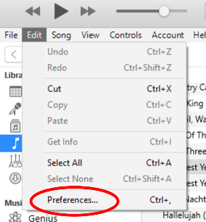Illustration 1
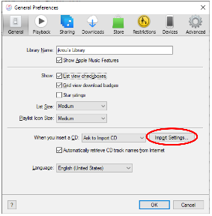Illustration 2

STEP 2. The Preferences dialog box appears, as shown in Illustration 2.

In that Preferences box, click the Import Settings button, which is circled in the illustration.

STEP 3. The iTunes Import Settings dialog box appears, as shown in Illustration 3.

Click the circled down-arrow to make the file format menu appear, as shown in the illustration. In that menu, select MP3 Encoder.

Then click the OK button in the Import Settings dialog box to close that box.
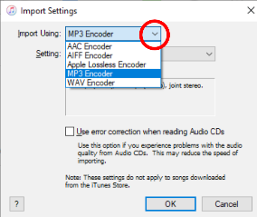Illustration 3

In the Preference box, click the OK button to close that box. That completes iTunes configuration for exporting M4A songs to MP3 format.

HOW TO EXPORT SONGS TO MP3 FILES USING ITUNES
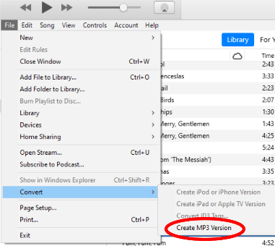Illustration 4
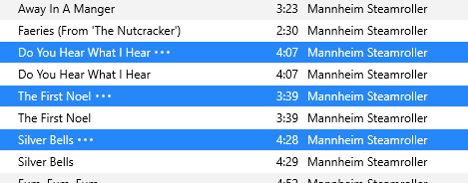Illustration 5

STEP 1. In iTunes, click on the Library tab to display your library of M4A song files.

STEP 2. In the library list of M4A song files, select the files you wish to convert to MP3 format. Note: conversion does not delete the selected M4A format song files. It simply adds MP3 files containing the same songs.

STEP 3. In iTunes, pull down the File menu, and select Convert. A sub-menu appears, as shown in Illustration 4. In that sub-menu, select Create MP3 Version, which is circled in the illustration.

That starts the conversion process. At the end of the process, each selected song will appear twice in the iTunes library. You can see an example in illustration 5, where the original files are selected, and each new MP3 file appears beneath the original MP4A file.

WHERE ARE THE NEW MP3 FILES?

iTunes places the new MP3 file in the same folder on disk where the original MP4 file is found for each file conversion.

In iTunes, you can right-click on the MP3 file to bring up a menu, and in that menu, select Show in Windows Explorer to open an Explorer window showing the contents of the folder.

ABOUT THE AUTHOR: John Krout has been writing about personal computers and creative uses since the early 1980s. He frequently writes for PATACS Posts and occasionally provides demos on tech topics at PATACS meetings. He lives in Arlington, VA, with his son, many computers and cameras, and too many cats.

